ICSID Regional Training Workshop 2019
26 - 28 September 2019
Meeting room, 10th floor, The Berkeley Hotel Pratunam
Bangkok, Thailand
----------------------------------------------------

Google Drive : Training Materials

- Link
https://drive.google.com/drive/u/0/mobile/folders/15Z1u787rcKuMfU894WwXGBtlKgc8vgTB?usp=sharing

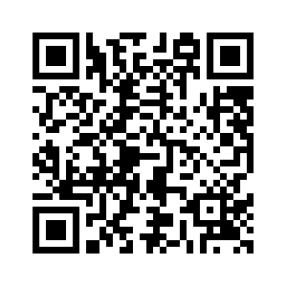
- QR Code

